Senate C&I Committee to the University Senate – March 21, 2016

Submitted by Michelle Rosen, Erin O’Neill, Billy Baker, Kathryn D’Alessandro, Wanda Rutledge, and Corinne Reilly-Ferretto

Courses Approved

College of Arts and Sciences

Economics Department
Econometrics
Credits: 3
Course Components: 3 lecture credit hours
Course Level: 300
Enrollment Cap: 25
Course Prerequisites: Math 140, Statistics I
This course introduces students to regression analyses in an economic context. It covers both the theory and application of regression analysis. It focuses on basic univariate and multivariate regression techniques and the assumption underlying the formal justification for why these techniques are valid. As well, this course also covers the interpretation of regression results.

Economics Department
History of Economic Thought
General Education Tier: 1
Modes of Inquiry: Social and Historical Perspectives
Credits: 3
Enrollment Cap: 20
Course Prerequisites: None
A systematic study of the history of economic ideas from the pre-industrial era to the modern age is presented in this course. It stresses the importance of understanding contemporary economics, by grasping new ideas, evidence, problems and values that call for reconsideration of basic disputes. The contributions of the great economists are examined in the context of the prevailing social and economic institutions.

Economics Department
Money and Markets
Credits: 3 undergraduate credits
Tier: 1
Mode: Social and Historical Perspective
Enrollment Cap: 20
Catalog Description: This course will provide the student with an overview of Micro and Macroeconomics. Issues to be discussed will include the function of the market process and its relation to the consumer and the firm. Fiscal and Monetary policy will be reviewed and the impact of these two policies on both domestic and international issues will be discussed.

Psychology Department
Social Psychology of Everyday Life
General Education Tier: 1
Modes of Inquiry: Scientific and Quantitative Studies
Credits: 3
Enrollment Cap: 20
Course Prerequisites: None
Course Description: By integrating core social psychology theories and concepts and enhancing the student’s ability to engage in scientific inquiry, The Social Psychology of Everyday life will show how social psychologists apply knowledge toward understanding and solving real-world problems. Special attention will be paid to socially and personally relevant topics, such as responding to and reducing prejudice, increasing health and happiness, interpersonal attraction and close relationships.

History Department
The US in the World
General Education Tier: 2
Modes of Inquiry: Social and Historical Perspectives
Credits: 3
Enrollment Cap: 20
Course Prerequisites: None
Catalog Description:
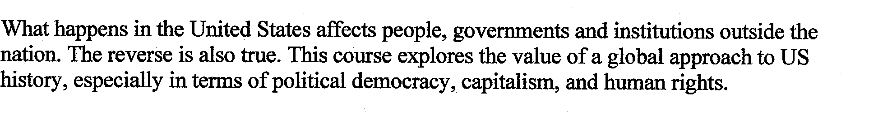

ESL Department
English Composition I for Bilingual Speakers
General Education Tier: 1
Modes of Inquiry: n/a
Credits: 6
Enrollment Cap: 20
Course Prerequisites: None
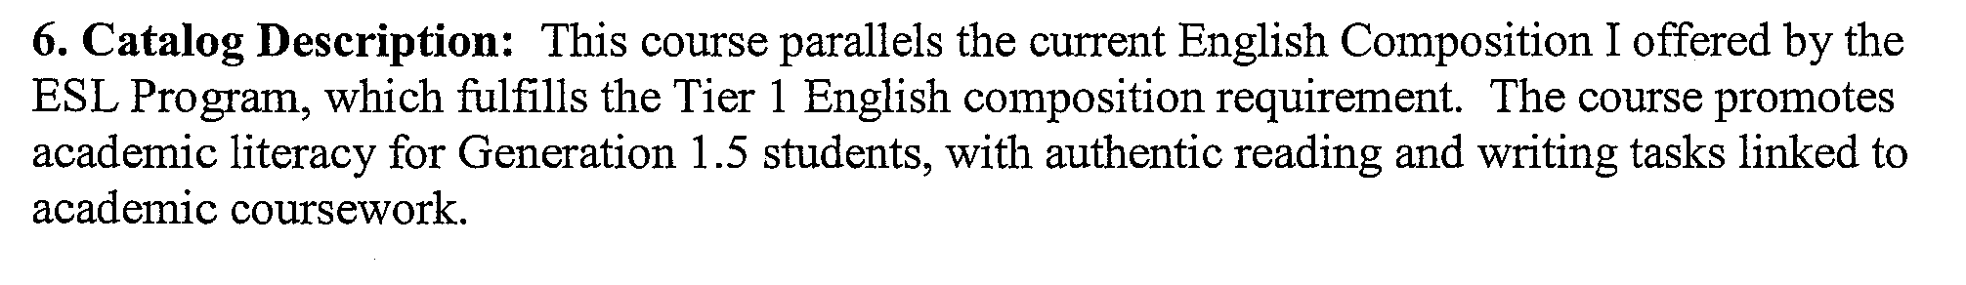

Math Department
Algebra for College Students
Course Level: 100
Credits: 3
Enrollment Cap: 20
Course Prerequisites: Developmental Math or placement by exam
Course Co-requisite: Beginning Algebra
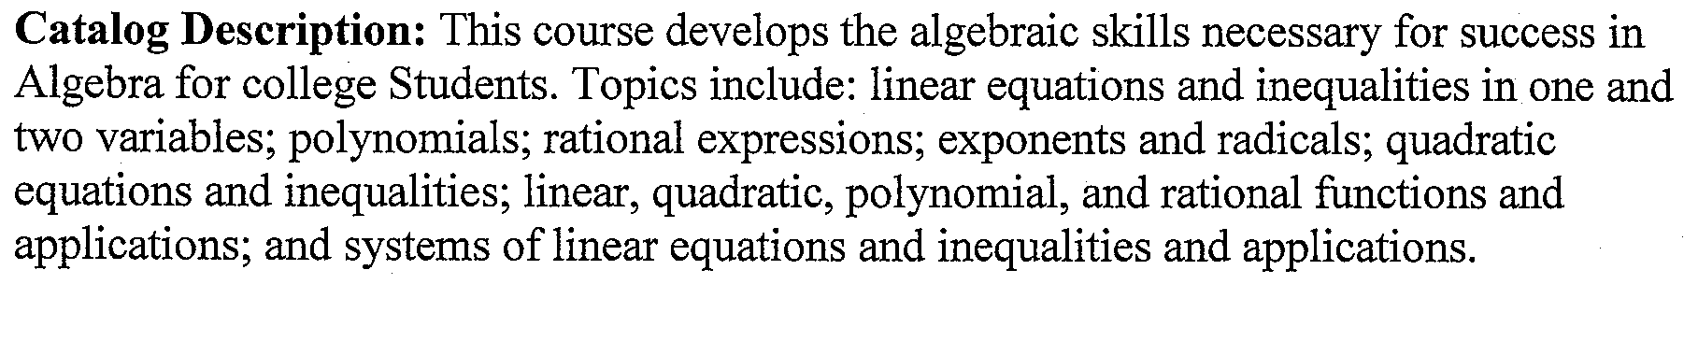

Math Department
Beginning Algebra
Course Level: 00
Credits: 2 (non-degree credits)
Enrollment Cap: 20
Course Prerequisites: Developmental Math or placement by exam
Course Co-requisite: Algebra for College Students
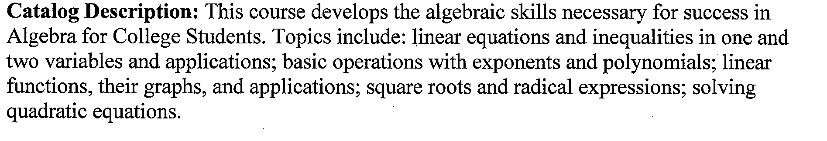

Modern Languages Department
Elementary Swahili I
Course Level: 100
Credits: 3
Enrollment Cap: 25
Course Prerequisites: none
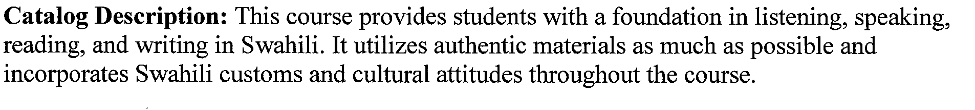

College of Professional Studies

Nursing Department
Contemporary Professional Practice for the Baccalaureate Nurse
Credits: 3
Course Components: 3 lecture credit hours
Course Level: 300
Enrollment Cap: 30
Course Prerequisites: English 1 and English 2 plus acceptance to Nursing Program
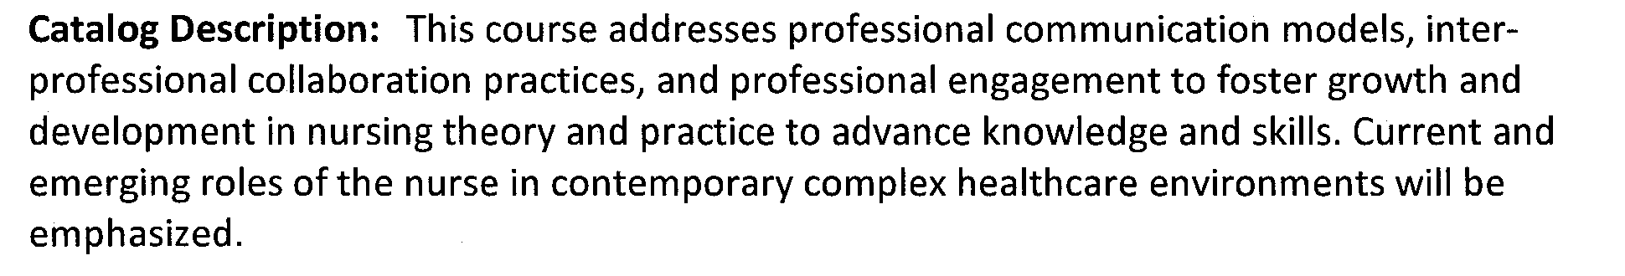

Nursing Department
Culture and Diversity in Nursing Practice
Credits: 3
Course Components: 3 credits theory
Course Level: 300
Enrollment Cap: 30
Course Prerequisites: Acceptance to Nursing major, English 101, English 102
Course Co-requisites: Nursing 3XX (Contemporary Professional Nursing for the Baccalaureate Nurse
Catalog Description: This course addresses expressions of health, illness, caring, and healing from trans-cultural focused perspectives. Culturally congruent nursing care practices encompassing individuals, families, groups, and communities are investigated and developed through Transcultural nursing theory, communication principles and ethics of social justice. A self-assessment approach is utilized to examine culture and diversity.

Nursing Department
Entry Level Nursing Practicum- Senior Capstone
Credits: 2
Course Components: 2 lecture credit hours
Course Level: 400 (replaces NUR 416, a 3 credit course)
Enrollment Cap: 30
Course Prerequisites: NURS 302, 3xx, 400, 4xx, 460
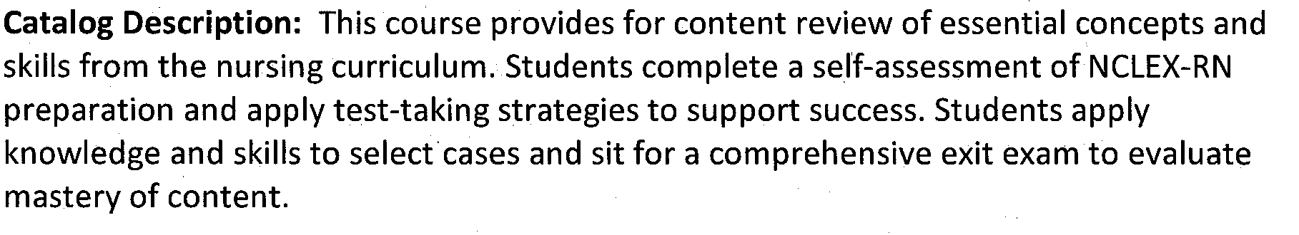

Nursing Department
Health Assessment for the Professional Nurse
Credits: 3
Course Components: 3 lecture credit hours
Course Level: 300
Enrollment Cap: 12 (as specified by the State Nursing Board
Course Prerequisites: English 1and 2, Biology 236, 237, 303, Microbiology plus acceptance to Nursing Program
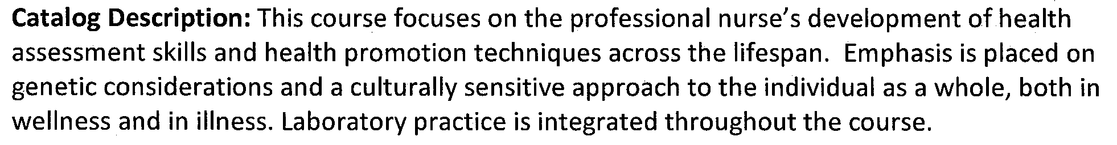

Department of Professional Security Studies
Ethical Hacking
Credits: 3
Course Components: 3 lecture credit hours
Course Level: 300
Enrollment Cap: 24 (due to room size)
Course Prerequisites: Computer Security I or Permission of Instructor
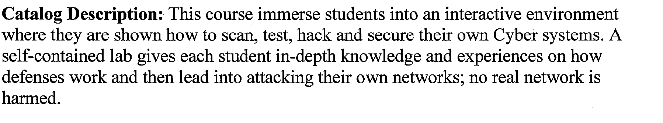

Department of Professional Security Studies
Computer Forensics
Credits: 3
Course Components: 3 lecture credit hours
Course Level: 300
Enrollment Cap: 25
Course Prerequisites: Computer Security I or Permission of Instructor
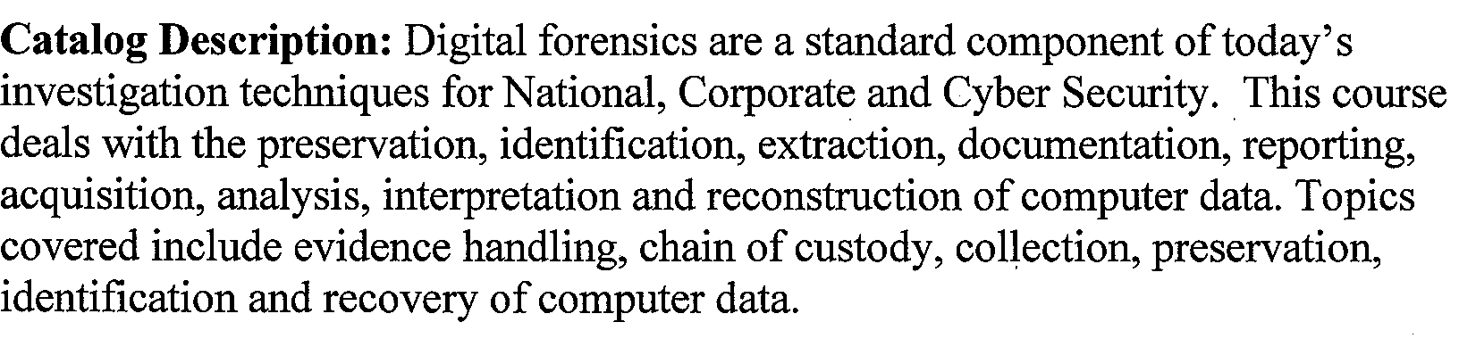

Approved Name Changes

Department Name Change:

Geoscience/Geography Department name change to the Department of Earth and Environmental Sciences

Course Name Changes:

Market Research to Market Research and Analytics

Film and Media Studies: contemporary European Film to Cinema and Media Studies:
Contemporary European Film

Approved Program Proposals

Minor in Military Science
Minor in Marketing
Minor Social Marketing
Math Major with Concentration in Actuarial Science
Minor in Public Relations
Change in Early Childhood Education Major

