Community Engaged Learning (CEL) at NJCU
Senate Motion

On behalf of the Faculty Fellows program, we move to:

Institutionalize CEL adding CEL to the CIM system as a type of instructional procedure and include a check-box on the course approval form that asks whether the course has been designed in consultation with the CEL Faculty Fellows;¹

Create a Senate Community Engaged Learning Committee that includes representatives from each of the colleges, at least one student and one a staff member, and an ex-officio representative from the Registrar’s office whose charge is to establish CEL policies and review CEL course proposals.²

Background:
In Fall 2017, President Henderson convened a group of Faculty Fellows to talk about curricular Civic Engagement at NJCU. In its first year, the Fellows chose the phrase Community Engaged Learning (CEL) to explain our critical pedagogical approach to enhance students’ understanding and engagement in the society, promote critical thinking, evidence-based decision-making and problem-solving, create a sense of civic duty, and expand critical skills in leadership, teamwork, and life-long learning. In these (current and imagined) courses, we take students out of the classroom and into the community to thoughtfully engage with social problems in partnership with community leaders, governmental agencies, or non-profit organizations. By combining project-based learning with academic instruction, students can begin to evaluate areas of practice, potential for change, and reflect on their place in the world. CEL courses also ensure that students have increased preparation for the workforce through enhanced ethics, knowledge, communication skills, and the ability to critically analyze and reflect on real world encounters.

CEL is a well-established, high-impact, active-learning teaching strategy. Through decades of research into the effects of CEL, CEL has been demonstrated to contribute to a richer teaching and learning experience, and contributes to student, faculty, and institutional priorities. CEL aligns with the NJCU mission to improve the “educational, intellectual, cultural, socioeconomic, and physical environment of the surrounding urban region and beyond”. Notably, CEL positively correlates with increases in GPA and retention (Kanwischer, Lilgreen, and Saralampi 2015).

CEL is unlike volunteerism, internships, co-ops, and applied learning. Volunteerism does not contain a curricular component and while internships and co-ops may have reflective assignments, they do not involve content learning or faculty classroom instruction. CEL is a middle balance wherein there is classroom instruction, a community placement, and assignments that are based on the community project. The Furco pyramid (pictured below) illustrates these differences.
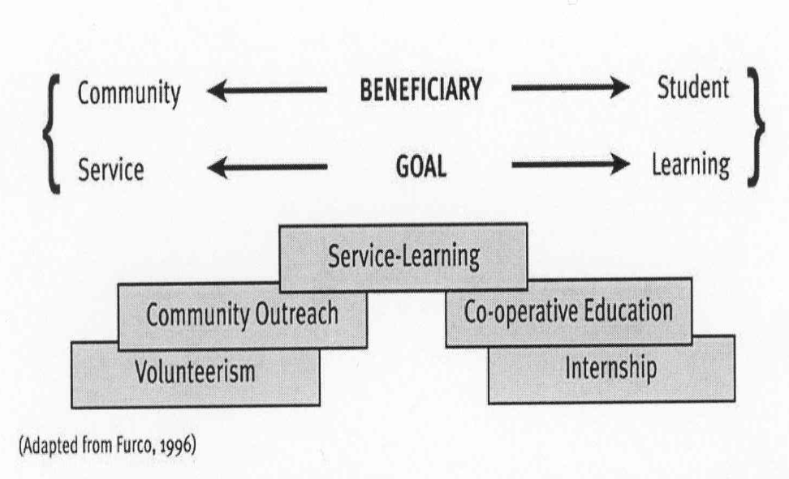
NJCU uses the phrase CEL rather than Service-Learning

Existing CEL courses at NJCU focus on issues such as poverty, food and housing insecurity, educational stratification, climate change, criminal justice reform, immigration hurdles, LGBTQ barriers to care, transportation deserts, health disparities, among other topics. CEL can be implemented in General Education, major, and Honors courses. CEL courses span all NJCU colleges (SoB, CoE, CPS, CAS) and represent many fields of inquiry. More faculty are developing new CEL courses and/or implementing CEL in existing courses.

Problem:
Currently, there is no formal approval process for CEL courses. There are no reviews done at the College and Senate level to ensure the quality and standards of CEL in these courses. GECC reviews General Education courses proposals with CEIK learning outcomes; however, while CEIK and CEL are naturally aligned, they are not the same because CEL is a type of instruction with its own guidelines. This means that any faculty can create a course and call it CEL without aligning the course with CEL field-recognized best practices.

Objective:
The goal is to grow the number of CEL offerings exponentially over the next several years so that NJCU can be approved for the Carnegie Community Engagement Classification.³ In order to build a culture of CEL, we need to create a designation process so that CEL courses are institutionally recognized as unique offerings by students, staff, and faculty alike.⁴

Notes:
¹ If a faculty member does not check this box, their course will go through the regular approval channels but it will not be recognized as a CEL course.
² This committee would operate like the GECC with elected members representing all colleges at NJCU. The committee would only meet when a CEL course is flagged in the approval system. The committee would meet before the course proceeds to the Senate C&I committee.
³ The Carnegie Community Engagement Classification “is awarded following a process of self-study by each institution, which is then assessed by a national review committee” at Albion College. “The classification has been the leading framework for institutional assessment and recognition of community engagement in U.S. higher education … “ (Association of Public and Land-Grant Universities 2020). Only 119 U.S. institutions have received this classification. In New Jersey, the following institutions are Carnegie classified: Rutgers University-New Brunswick, Rutgers University-Newark, Stockton University, Drew University, Montclair State University, Raritan Valley Community College, Rutgers University-Camden, Saint Peter’s University, and The College of New Jersey.
⁴ A model for our intention at NJCU can be found at our peer institution, Stockton University https://www.stockton.edu/service-learning/faculty/index.html

References
Association of Public and Land Grant Universities. 2020. “2020 Carnegie Community Engagement Classification Recipients Announced.” Association of Public and Land Grant Universities. February 4, 2020. https://www.aplu.org/news-and- media/blog/2020-carnegie-community-engagement-classification-recipients- announced
Furco, Andrew. 1996. “Service-Learning: A Balanced Approach to Experiential Education”. In Taylor, B. (ed.). Expanding boundaries: Serving and Learning. Washington: Learn and Serve America.
Carnegie Community Engagement Classification. Campus Compact. https://compact.org/initiatives/carnegie-community-engagement-classification/
CEL Faculty and Faculty Fellows. New Jersey City University. https://www.njcu.edu/academics/resources-services/community-engaged-learning/cel-faculty-faculty-fellows
Kanwischer, Wanda, Lilgreen, Amanda, and Monica Saralampi. 2015. “Service Learning as a College Involvement and Success Strategy for Underserved Student Populations.” The Journal for Civic Commitment 23 http://ccncce.org/articles/service-learning-as-a-college-involvement-and-success-strategy-for-underserved-student-populations/

Respectfully submitted by members of President Henderson’s Faculty Fellows on Civic Engagement with endorsement by NJCU Senators Drs. Jennifer Musial, Yufeng Wei, Peri Yuksel, and EunSu Lee and the Academic Support and Services Committee.

