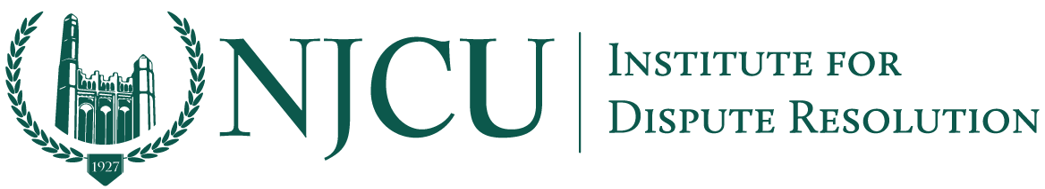
Connecting Bridges and Borders Program
⎻⎻⎻
Entrepreneurship and Innovation NJCU—Jersey City Connect Project

Wall Street Investments In the Post-Pandemic World: What Does the Future Hold?
https://www.youtube.com/watch?v=x-kQ-t3quBk
Jersey City, June 23, 2020—This week on “Connecting Bridges and Borders,” Professor David Weiss speaks with Peter J. Lewis to discuss the immediate and long term effects of the COVID-19 pandemic on the American economy. Peter Lewis has been with Murphy Capital Management Inc. for over 15 years, and is currently the president of the Investment Advisory Firm.

Lewis highlights the collapse of the American economy from 2019 to 2020. Last year’s low unemployment rate brought hope to the American people, but the onset of COVID-19 has quickly reversed much of the economic progress made during Trump’s presidency. The COVID-19 pandemic, as Lewis puts it, has affected “every conceivable industry,” and has left millions clambering to remain afloat. While these are unprecedented times, Lewis remains level-headed about the situation at hand and discloses some strategies businesses and investors can implement to recover post-pandemic.

Follow the link above to join Professor Weiss and Peter Lewis as they provide insight and advice on navigating these uncertain times.

About Us
The Institute for Dispute Resolution at NJCU is a platform under the School of Business that seeks to promote international negotiation and mediation techniques to manage disputes in cross border commercial and general conflict resolution forums.
Contact
Darby Zelaskowski, Public Relations
dzelaskowski01@manhattan.edu
https://www.njcu.edu/academics/schools-colleges/school-business/institute-dispute-resolution-idr

