Senate C&I Committee to the University Senate – November 30, 2015REVISED
Approved 11.22.15

Submitted by Michelle Rosen, Erin O’Neill, Billy Baker, Kathryn D’Alessandro, Wanda Rutledge, and Corinne Reilly-Ferretto

Courses Approved

College of Arts and Sciences
Art Department
Acts of Resistance: Activists + Interlopers + Prankster
Credits: 3 credits/semester hours
General Education Tier: 2
GED Mode of Inquiry: Cultural Studies/Social Perspectives
Enrollment Cap: 20
Course Prerequisites or Co-requisites: None
This is a course about media subversives. People working outside of mainstream media institutions, who nonetheless find creative and provocative ways to use the media for cultural, political, or economic critique and resistance. Over the course of the semester, we will examine a range of “alternative” media phenomena.
College of Arts and Sciences
Art Department
Body Adornment: Design, Culture and History
Credits: 3 credits, 4 contact hours
Course Components: Studio and lecture
General Education Tier: 2
GED Mode of Inquiry: Creative Process and Production and Social
and Historical Perspectives.
Enrollment Cap: 12
Body adornment has always played a significant role in human history and culture. Students in this course will create studio jewelry and examine body adornment through diverse cultural perspectives and how it informs cultural standards of beauty, social and religious obligations and serves as a form of personal communication.
Course Prerequisites or Co-requisites: None

College of Arts and Sciences
Art Department
Empower Tools: Art as a Catalyst for Social Change
Credits: 3 credits, 4 contact hours
Course Components: Studio and lecture
General Education Tier: 1
GED Mode of Inquiry: Creative Process and Production
Enrollment Cap: 16
This course investigates the cultural significance of artmaking, as a means to create positive social change. Students will develop a practical understanding of ceramics, collage and new media through the lens of artistic activism to become practicing conceptual artists, as well as active and engaged citizens.
Course Prerequisites or Co-requisites: None

College of Arts and Sciences
Music, Dance, Theater Department
Masters and Innovators in U.S. Music: Billings to Tupac and Beyond
Credits: 3 credits
Course Components: lecture
General Education Tier: 1
GED Mode of Inquiries: Creative Process and Production and Historical Perspectives
Enrollment Cap: 20
Billings to Tupac and Beyond examines U.S. composers and performers who ameliorated the art form. From musical, sociological, and historical perspectives, it analyzes their creative process, effect on society, and how historians view them. Students evaluate
historical documents, textbooks, music artifacts, and create projects in their areas of interest.
Course Prerequisites or Co-requisites: None

School of Business
Management Department
Business Enterprise Applications
Credits: 3 credits
Course Components: lecture
Level: 200
Enrollment Cap: 25
This course provides a foundation in current business software and applications. It prepares students for certification in the most widely used software and business applications, including but not limited to Excel and Bloomberg Essentials, an introduction to Word, PowerPoint and other business-related technology. No prior computer experience is necessary.
Course Prerequisites or Co-requisites: None

College of Arts and Sciences
History Department
Cities in History
Credits: 3 credits
Course Components: lecture
General Education Tier: 2
GED Mode of Inquiry: Social and Historical Perspectives
Enrollment Cap: 25
In this course students will analyze case studies of ancient, Greek and Roman, medieval,
renaissance, imperial, industrial and global cities. Spanning continents and centuries, and case study cities correlating to the instructor’s expertise, this course helps students explore city influence through natural resources, cultural and political imperialism, economics, and natural disasters.
Course Prerequisites or Co-requisites: None

College of Arts and Sciences
History Department
Cranks and Critics
Credits: 3 credits
Course Components: lecture
General Education Tier: 1
GED Mode of Inquiry: Social and Historical Perspectives
Enrollment Cap: 25
This course looks at various efforts to create and live the perfect life. Were the people behind these efforts outcasts and weirdos? Absolutely. But their nonconformity and critique of materialism gives us a chance to reflect on what it means to be happy and live on one's own terms.
Course Prerequisites or Co-requisites: None

College of Arts and Sciences
Women’s Gender Studies Department
Diversity and Difference: Identities, Communities, and Cultures
Credits: 3 credits
Course Components: lecture
General Education Tier: 1
GED Mode of Inquiry: Social and Historical Perspectives
Enrollment Cap: 25
This course is designed to explore how culture shapes individual and community identities. It provides students with social, political, cultural, psychological, and historical frameworks for understanding differences and resolving conflicts. Students will build a repertoire of skills for identifying, researching, analyzing, navigating, and valuing diversity.
Course Prerequisites or Co-requisites: None

College of Arts and Sciences
Geoscience/Geography Department
Earth 360°: Integrated Geography
Credits: 3 credits
Course Components: lecture
General Education Tier: 2
GED Mode of Inquiry: Scientific and Quantitative Inquiry
Enrollment Cap: 20
This course explores Earth’s deep and surface processes, and examines landscapes of human activities. It focuses on global patterns and processes, and their spatial and temporal variations at specific locations throughout the world. Students also discuss environmental aspects of interactions between humans and their natural settings.
Course Prerequisites or Co-requisites: None

College of Arts and Sciences
Math Department
Enhanced Precalculus
Credits: 4 credits
Course Components: lecture
General Education Tier: 1
GED Mode of Inquiry: n/a
Enrollment Cap: 25
Selected topics from algebra, exponential and logarithmic functions, and trigonometry are chosen to provide a suitable background for Calculus 1.
Course Prerequisites: Algebra for College Students or equivalent

College of Arts and Sciences
Psychology Department
Exploring Human Sexuality
Credits: 3 credits
Course Components: lecture
General Education Tier: 1
GED Mode of Inquiry: Scientific and Quantitative
Enrollment Cap: 25
Discover what you always wanted to know about sex, but were afraid to ask. In Exploring
Exploring Human Sexual Behavior, you will learn about the complexity of human sexuality, the
variety of human sexual behaviors, and the techniques psychologists use to study sexual
behavior.
Course Prerequisites or Co-requisites: none

Department of Finance
Financial Literacy: Strategies for Financial Success
Credits: 3 credits
Course Components: lecture
General Education Tier: 2
GED Mode of Inquiries: Scientific and Quantitative Mode of Inquiry plus Social and
Historical Perspectives.
Enrollment Cap: 20
Students will explore behaviors necessary to make ethical and realistic financial decisions in changing situations and evaluate their collective societal impact. In a cultural and civic context, learners will develop lifelong strategic financial management skills to grow into responsible citizens, smart consumers and successful economic units.
Course Prerequisites or Co-requisites: None

Geoscience/Geography
Global Climate Change: Past and Future
Credits: 3 credits
Course Components: lecture
General Education Tier: 2
GED Mode of Inquiries: Scientific and Quantitative Mode of Inquiry plus Social and
Historical Perspectives.
Enrollment Cap: 20
This course introduces principles of Earth’s climate systems, and discusses evidence for past, present and future climate change. Students examine natural and anthropogenic climate forcing agents, negative and positive feedback mechanisms. The course focuses on social, historical and environmental aspects of climate change, and thus aims to promote climate-science literacy.
Course Prerequisites or Co-requisites: None

College of Arts and Sciences
Department of Philosophy and Religion
Food, Philosophy and Global Health
Credits: 3 credits
Course Components: lecture
General Education Tier: 2
GED Mode of Inquiries: Language, Literary, and Cultural Studies and Social and
Historical Perspectives.
Enrollment Cap: 20
Food, Philosophy and Global Health explores our relationship with food through the lens of philosophy. Using ethics, logic, and critical thinking, we investigate current debates and examine how collective choices impact the health of the planet. Using these insights, we develop a community action program that empowers an underserved community.
Course Prerequisites or Co-requisites: None

College of Arts and Sciences
Department of Philosophy and Religion
The Examined Life
Credits: 3 credits
Course Components: lecture
General Education Tier: 1
GED Mode of Inquiry: Language, Literary, and Cultural Studies
Enrollment Cap: 20
This course teaches students to identify and evaluate those beliefs that guide their thoughts and actions. Reflecting on different sources, students identify those philosophical beliefs that play a role in their own lives. By developing their critical thinking skills, they learn how to clarify, systematize, and assess these beliefs.
Course Prerequisites or Co-requisites: None

College of Arts and Sciences
Department of Philosophy and Religion
The Philosophy of Social Justice in the United States
Credits: 3 credits
Course Components: lecture
General Education Tier: 2
GED Mode of Inquiry: Social and Historical Perspectives
Enrollment Cap: 25
This course will provide an overview of social justice topics including: poverty, unemployment, the welfare state, racial discrimination, gender discrimination, and income inequality. The readings for the course will include contemporary philosophic, sociological, and economic writings. Contemporary data sources will also be utilized.
Course Prerequisites or Co-requisites: None

College of Arts and Sciences
Department of Philosophy and Religion
Practice, Policy and Philosophy of Education
Credits: 3 credits
Course Components: lecture
General Education Tier: 2
GED Mode of Inquiry: Language, Literary, and Cultural Studies and Social and
Historical Perspectives.
Enrollment Cap: 25
This course will introduce students to the essential concepts, precepts and methods of
Philosophy of education. Students will use these foundations to reflect on the basic aspects of human learning as well as become effective participants within the milieu of modern education.
Course Prerequisites or Co-requisites: None

College of Arts and Sciences
Art Department + Fitness, Exercise & Sports Department
Self: I As Body
Credits: 3 credits
Course Components: lecture
General Education Tier: 2
GED Mode of Inquiry: Creative Process/Production
Scientific and Quantitative
Enrollment Cap: 15
This course is divided into two broad components that bridge a creative and scientific
approach to understanding self-identity and the human form. Students study anatomy, the
human nude and engage in physical activity. This course connects knowledge, creativity and somatic experience to explore the human form and identity.
Course Prerequisites or Co-requisites: None

College of Arts and Sciences
Math Department
Statistics I
Credits: 3 credits
Course Components: lecture
General Education Tier: 1
GED Mode of Inquiry: n/a
Enrollment Cap: 15
Statistics I is a study of mode, median, mean, standard deviation,
various descriptive techniques, the binomial and normal distributions, and an introduction
to statistical inference. Statistical concepts are applied primarily to the natural and social
sciences, business administration, and criminal justice using packaged software such as
Minitab and SPSS.
Course Prerequisites: Algebra for college students (Proposed new
course) or its equivalent.

College of Arts and Sciences
Women’s and Gender Studies Department
Telling Women’s Lives
Credits: 3 credits
Course Components: lecture
General Education Tier: 1
GED Mode of Inquiry: Language, Literary, and Cultural Studies
Enrollment Cap: 20
In this course, students will use feminist analysis to examine the cultural processes of telling and hearing women’s stories and to consider how these narratives create knowledge within multiple disciplines. Students will hear, read and re-tell the life experiences of women using oral and written texts drawn from various genres.
Course Prerequisites or Co-requisites: None

College of Arts and Sciences
Media Arts Department
“Understanding Movies: The Art Of Film”
Credits: 3 credits
Course Components: lecture
General Education Tier: 1
GED Mode of Inquiries: Language, Literary, and Cultural Studies and Social and Historical Perspectives
Enrollment Cap: 25
This course introduces the student to films, filmmakers, and the vocabulary of the movies. The course will explore the techniques specific to film –from script to screen - and the functions of directors, actors, producers, writers, etc. Students will analyze and view films from historical, social, and critical contexts.
Course Prerequisites or Co-requisites: None

College of Arts and Sciences
Women’s and Gender Studies
Women, Hip Hop, Spoken Word and Social Change
Credits: 3 credits
Course Components: lecture
General Education Tier: 1
GED Mode of Inquiries: Creative Process and Production and Social and Historical Perspectives
Enrollment Cap: 25
This course will examine the sociopolitical and cultural role Hip Hop and spoken word plays in social activism in a global context. Students will examine the intersection of race, class, gender and sexuality within the genre of spoken word and Hip Hop in social transformation.
Course Prerequisites or Co-requisites: None

College of Arts and Sciences
History Department
Beyond Boundaries: Historical Narrative in the Global Age (1,000 CE to Present)
Credits: 3 credits
Course Components: lecture
General Education Tier: 2
GED Mode of Inquiries: Language, Literary, and Cultural Studies and Creative Process and Production
Enrollment Cap: 25
This course explores globalization as a cultural interchange subject to divergence, convergence, contagion, and systemization. Students build empathy skills and detect biases in sources through close reading and historical inquiry. In final projects, students research the historical context of immigrant communities and write annotated historical narratives about immigrants they interview.
Course Prerequisites or Co-requisites: None

College of Arts and Sciences
Math Department
Calculus for Business
Credits: 3 credits
Course Components: lecture
General Education Tier: 2
GED Mode of Inquiry: Scientific and Quantitative Mode of Inquiry
Enrollment Cap: 25
This course introduces the student to the role of calculus in business. Topics include: limits,
continuity, derivatives and applications, and integration and applications.
Course Prerequisites: Precalculus for Business Students or equivalent

College of Arts and Sciences
English Department
English Composition
Credits: 4 credits
Course Components: lecture/writing lab
General Education Tier: 1
GED Mode of Inquiry: n/a
Enrollment Cap: 20 or 15 for ALP
This course introduces students to the basic communicative skills needed in college-reading, writing, speaking, and listening-through the interpretation of textual, visual, and digital materials. It also provides an introduction to research skills.
Course Prerequisites or Co-requisites: adequate score on writing placement test or the writing and reading profile (WRAP) exam.

College of Arts and Sciences
Political Science Department
Global Challenges
Credits: 3 credits
Course Components: lecture
General Education Tier: 1
GED Mode of Inquiry: Social and Historical Perspectives.
Enrollment Cap: 15
This survey course is designed to expose students to the leading global issues confronted by the “global village.” It provides students with the knowledge, skills, attitudes, and service learning opportunities to explore solutions to global challenges that will shape our world in the next 25-30 years.
Course Prerequisites or Co-requisites: None
School of Business
Management Department
Decision Intelligence in Supply Chains
Credits: 3 credits
Course Components: lecture
Level: 400
General Education Tier: 1
GED Mode of Inquiry: n/a
Enrollment Cap: 25
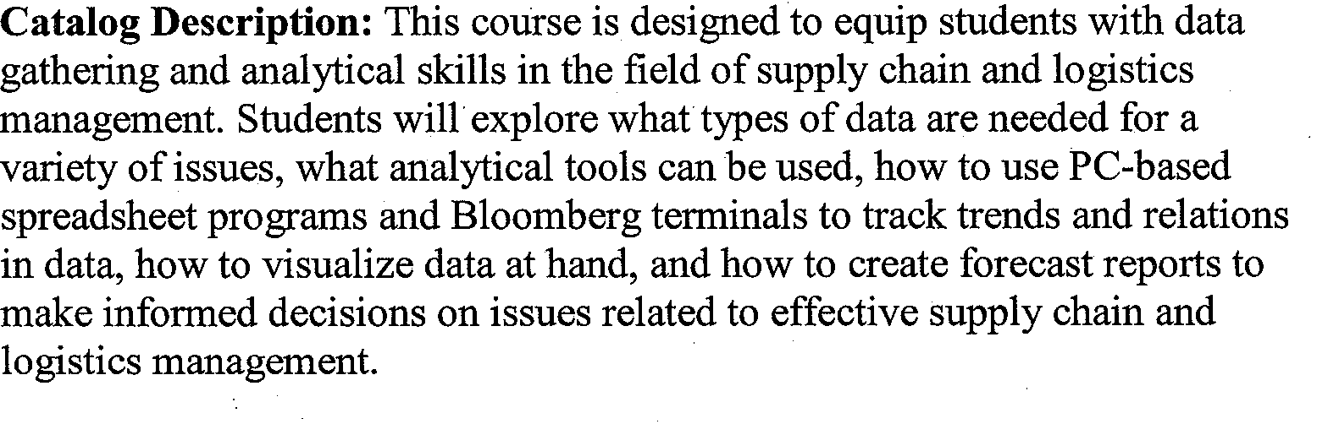
Course Prerequisites or Co-requisites: Successful completion of Business Enterprise Application, Operations and Project Management Fundamentals, Business Statistics.

School of Business
Management Department
Logistics and Transportation Management
Credits: 3 credits
Course Components: lecture
Level: 300
Enrollment Cap: 25
This course is designed to provide a foundation in Logistics and Transportation Management. Students will be exposed to key components involved in the operations of supply chains and evaluate their corresponding transportation options to maximize the efficiency. The fundamental principles utilizing multiple modes of transportation to include air, maritime, and ground transportation will also be explored.
Course Prerequisites or Co-requisites: Successful completion of Business Enterprise Application, Operations and Project Management Fundamentals, Business Statistics.
College of Arts and Sciences
Media Arts Department
The Media Revolution of the 1960s
Credits: 3 credits
Course Components: lecture
General Education Tier: 2
GED Mode of Inquiry: Social and Historical Perspectives.
Enrollment Cap: 25
In this course, students will examine the impact of electronic media on the social and political climate of the 1960s. Through lecture, video illustration, workshops, written reflections and discussions, students will become familiar with the salient issues of the decade and of the profound impact new media had in framing those issues and contributing to accompanying changes in perspectives, understandings and behavior.
Course Prerequisites or Co-requisites: None
College of Arts and Sciences
Music Dance and Theater Department
Music Now: Understanding Contemporary Music
Credits: 3 credits
Course Components: lecture
General Education Tier: 2
GED Mode of Inquiry: Language, Literary, and Cultural Studies
Enrollment Cap: 25
This course illustrates the theories behind noise, avant-garde classical music, pop, jazz, ambient, and electronic music. Students will examine the interconnections among such forms as minimalism, indeterminacy, musique concrète, experimental music, avant-rock, dub reggae, ambient music, HipHop, Techno, and other current trends through writings by philosophers, cultural theorists, and composers.
Course Prerequisites or Co-requisites: None

School of Business
Management Department
Operations and Project Management Fundamentals
Credits: 3 credits
Course Components: lecture
Course Level: 200
Enrollment Cap: 25
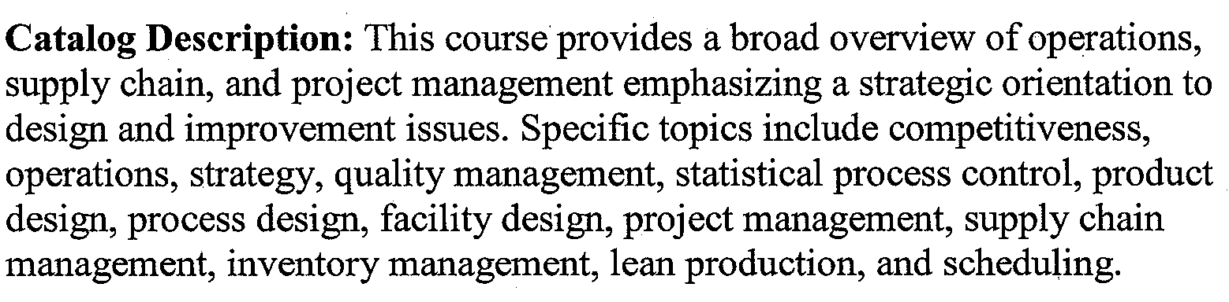
Course Prerequisites or Co-requisites: Business Enterprise Applications

School of Business
Management Department
Procurement and Supplier Relationship Management
Credits: 3 credits
Course Components: lecture
Course Level: 300
Enrollment Cap: 25
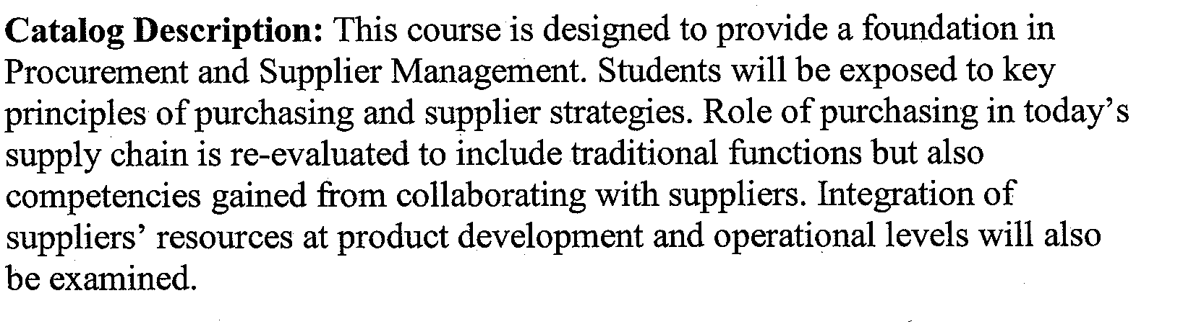
Course Prerequisites or Co-requisites: Business Enterprise Applications, Operations and Project Management Fundamentals, Business Statistics

School of Business
Management Department
Seminar: Supply Chain, Logistics, and Maritime Port Management
Credits: 3 credits
Course Components: lecture
Course Level: 500 (undergraduate)
Enrollment Cap: 25
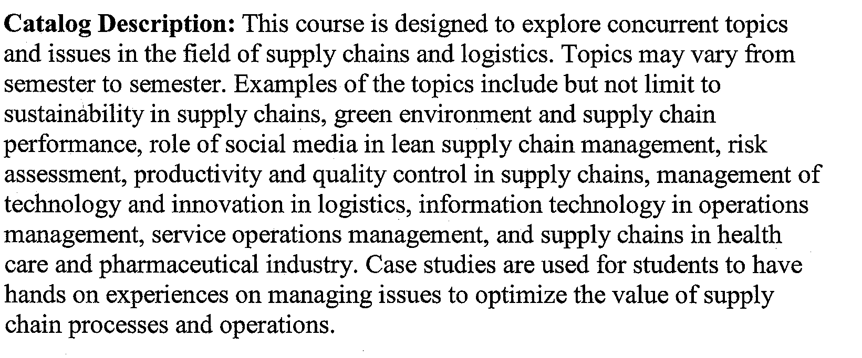
Course Prerequisites or Co-requisites: Business Enterprise Applications, Operations and Project Management Fundamentals, Business Statistics

School of Business
Management Department
Introduction to Supply Chain, Logistics, and Port Management
Credits: 3 credits
Course Components: lecture
Course Level: 300
Enrollment Cap: 25
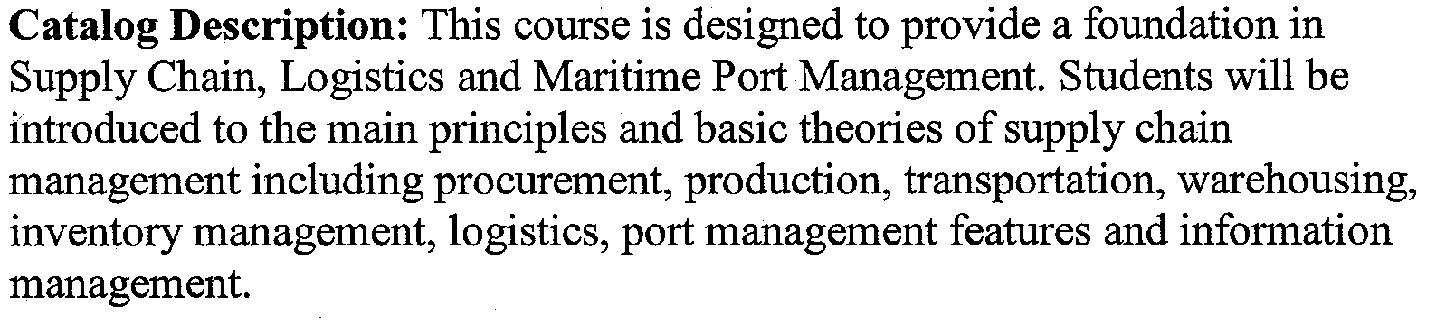
Course Prerequisites or Co-requisites: Business Enterprise Applications, Operations and Project Management Fundamentals, Business Statistics

College of Arts and Sciences
Women’s and Gender Studies department
Women and Leadership: Work and Community
Credits: 3 credits
Course Components: lecture
General Education Tier: 2
GED Mode of Inquiry: Social and Historical Perspectives.
Enrollment Cap: 25
Students will explore the experiences, strategies, and gendered dynamics affecting women in leadership roles. Beginning with historical examples of political leaders, social activists, and business entrepreneurs, students will examine contemporary issues facing women leaders in workplace and community settings and will create toolkits for exploring and enacting their own leadership potential.
Course Prerequisites or Co-requisites: None
College of Arts and Sciences
English and Art Departments
Cut, Copy, Paste: Creative Approaches to Writing and Design
Credits: 3 credits
Course Components: lecture, Studio, 4 hours. Course meets for 4 contact hours/week
General Education Tier: 2
GED Mode of Inquiries: Creative Process and Production and Language, Literary, and Cultural Studies
Enrollment Cap: 15
Bringing together verbal and visual creative work, students will analyze and practice written forms that use visual elements. They will study traditional and experimental book and magazine design and production. Students will create book and digital media projects, like zines, featuring the class's own writing and visual productions.
Course Prerequisites or Co-requisites: None
College of Arts and Sciences
Women and Gender Studies Departments
Women and Leadership: Work and Community
Credits: 3 credits
Course Components: lecture, Studio, 4 hours. Course meets for 4 contact hours/week
General Education Tier: 2
GED Mode of Inquiry: Social and Historical Perspectives
Enrollment Cap: 25
Students will explore the experiences, strategies, and gendered dynamics affecting women in leadership roles. Beginning with historical examples of political leaders, social activists, and business entrepreneurs, students will examine contemporary issues facing women leaders in workplace and community settings and will create toolkits for exploring and enacting their own leadership potential.
Course Prerequisites or Co-requisites: None
College of Arts and Sciences
ESL Department
English Composition 1 for ESL Students
Credits: 6 credits
Course Components: lecture, Studio, 4 hours. Course meets for 4 contact hours/week
General Education Tier: 1
GED Mode of Inquiry: n/a
Course Level: 100
Enrollment Cap: 20
Catalog Description: This course parallels the current English Composition I offered by the ESL Program, which fulfills the Tier 1 English composition requirement. The course promotes academic literacy for ESL students, with authentic reading and writing tasks linked to academic coursework.

Course Prerequisites or Co-requisites: None
College of Arts and Sciences
Media Arts Department
The History of Media
Credits: 3 credits
Course Components: lecture
General Education Tier: 1
GED Mode of Inquiry: Social and Historical Perspectives
Enrollment Cap: 25
In this course, students will analyze the history of media from the beginnings of speech up until the introduction of television in the 1950s and 1960s. Through lecture, video illustration, interactive role play activities and discussions, students will become familiar with some of the major developments in the history of media and of their consequences on society.
Course Prerequisites or Co-requisites: None
College of Arts and Sciences
Political Science Department
International Political Economy
Credits: 3 credits
Course Components: lecture
General Education Tier: 2
GED Mode of Inquiry: Social and Historical Perspectives
Enrollment Cap: 25
This course provides an introduction to the interplay of politics and economics in the international and domestic arenas. Within the general historical and theoretical frameworks that guide the study of international political economy (IPE), it examines the interaction of states, markets, and social forces across various issue areas of IPE.
Course Prerequisites or Co-requisites: None
College of Arts and Sciences
Art Department
Passion for Painting: An Enduring and Meaningful Art Form
Credits: 3 credits, 4 contact hours
Course Components: lecture
General Education Tier: 1
GED Mode of Inquiry: Creative Process and Production
Enrollment Cap: 15
Through learning the personal histories of master artists, students will examine why painting persists as an art form and remains relevant in contemporary culture. The class will include research writing, lectures, museum field trips, oral presentation, instruction and completion of hands-on studio activities.
Course Prerequisites or Co-requisites: None
College of Arts and Sciences
Art Department
Websites for Everyone: Implementing Wordpress (CMS) Sites for Business and Self-promotion
Credits: 3 credits, 4 contact hours
Course Components: lecture
General Education Tier: 1
GED Mode of Inquiry: Creative Process and Production
Enrollment Cap: 15
Using open source Content Management Systems such as Wordpress, students will create a website. They will analyze the requirements for their site, design and compose original
content, prepare digital media, customize code, and optimize for effective delivery.
Course Prerequisites or Co-requisites: None

College of Arts and Sciences
History Department
The Twentieth Century Middle East
Credits: 3 credits
Course Components: lecture
Course Level: 300
Enrollment Cap: 25
Catalog Description: This course examines how Middle Eastern societies adapted to social, economic, and political changes from the Young Turk Revolution of 1908 to the Arab Spring. Major topics include World War I, the Israeli-Palestinian Conflict, Pan-Arabism, the Iranian Revolution, political Islamism, and developments in literature, law, art, and family life.
Course Prerequisites or Co-requisites: Any 100 or 200 level history course

Approved Name Change:
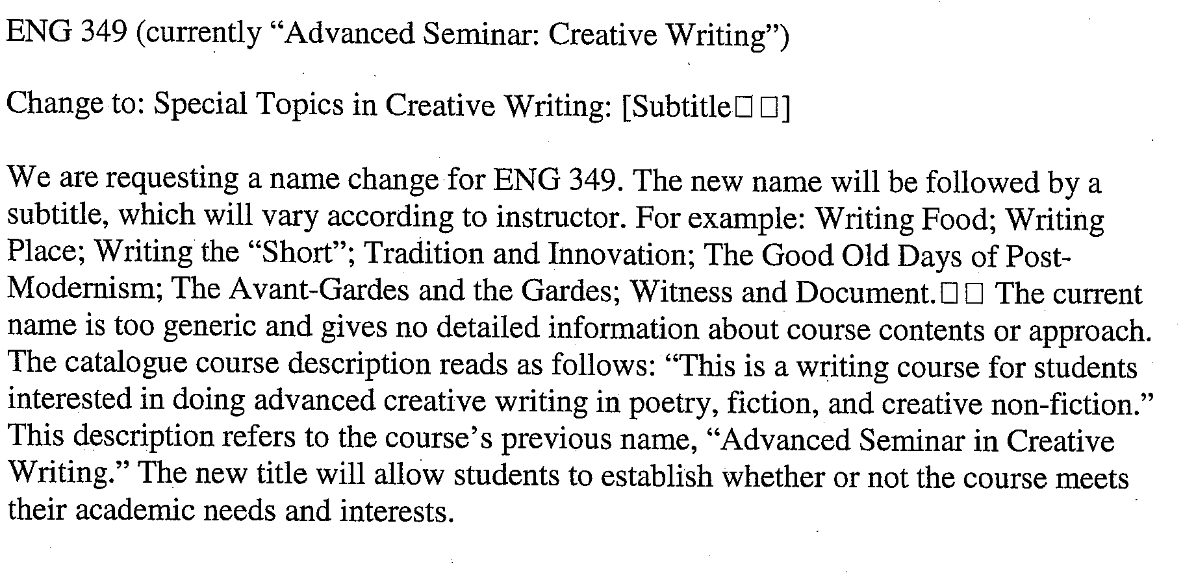
Approval for COURSE CHANGE-POLI & SOCIAL FROM 100-200

