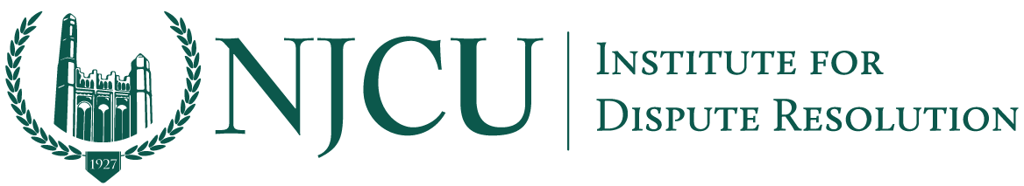
Connecting Bridges and Borders Program
⎻⎻⎻
Entrepreneurship and Innovation NJCU—Jersey City Connect Project

Director and Founder Professor David Weiss to Participate in Free Webinar “Enforcing mediated settlement NOW in a flat world”

Jersey City, May 5, 2020—Join International Mediation Institute (IMI) Certified Mediators David Weiss, Laura Kaster, Jennifer Brandt, and Robert Margulies in a free online webinar on May 8, 2020 at 9:00am (EST) as they discuss the New Jersey Statute that will make way for Consent Awards to be awarded after a mediated resolution of cross-border disputes.

“IMI are delighted to be co-sponsoring this event on how enforceability can be realistically enacted in different jurisdictions, meaning mediation will become an increasingly valuable tool for dispute resolution around the world” - Laura Skillen, IMI Executive Director

“The partnership with IMI and NJCU IDR has a long standing history we are so proud of at NJCU. I am looking forward to highlighting our academic contributions made to create NJ policy for enforcement of cross border commercial disputes through a mediation and arbitration award process. This NJ Model now enables our state to take a place on the global stage to help promote international business” — Professor David Weiss, Founder and Director of the IDR

“The pandemic has challenged everyone on earth. If cross border business is to build again and thrive we must have online cost effective ways to resolve disputes efficiently. IMI’s Global Pound meetings established the demand for mediation solutions. The Global Exchange Mediation Center (GMXC) administers New Jersey’s new law that permits a hybrid arbitration and mediation that can result in a consent award enforceable around the world. Join IMI, NJCU, And GMXC’s free webinar to see what innovation looks like.” — Laura Kaster, 2018 winner of the Richard K. Jeydel Award for ADR Excellence from the Garibaldi ADR Inn of Court

“The development of the Singapore Convention was a great step forward for cross border mediation. However, while the Convention is being ratified around the world, New Jersey has a tool available right now to enhance confidence in cross border mediation. This webinar on Friday will explain the benefits of using the New Jersey law to enforce mediation settlements and how the Global Exchange Mediation Center can help you. I urge you to attend.” — Deborah Masucci, Global Expert in Alternative Dispute Resolution and Dispute Management

Register to Watch
https://www.imimediation.org/2020/05/04/enforcing-mediated-settlement-now-in-a-flat-world/

About Us
The Institute for Dispute Resolution at NJCU is a platform under the School of Business that seeks to promote international negotiation and mediation techniques to manage disputes in cross border commercial and general conflict resolution forums.

Contact
Darby Zelaskowski, Public Relations
dzelaskowski01@manhattan.edu
https://www.njcu.edu/academics/schools-colleges/school-business/institute-dispute-resolution-idr

