Scholarships
presented by Student Government Association
New Jersey City University

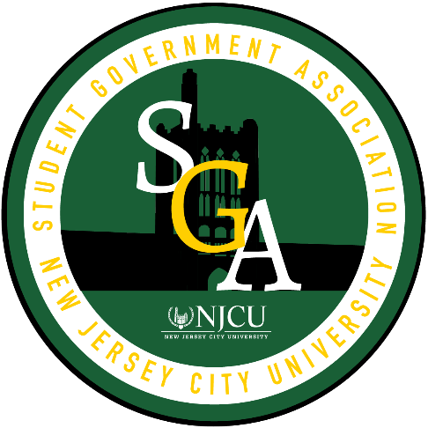

NJCU’s Student Government Association designed these scholarships to address the needs of our students. We hope these motivate and support our students as they progress through their academic journey and succeed at NJCU.

Eligibility and award amounts vary by scholarship category. Please review the ones you are interested in and email SGA Executive Vice President Alan Cruz at acruz6@njcu.edu for any questions or concerns.

Every student can apply for up to TWO scholarships each semester! Students are only eligible to win ONE scholarships per semester.
https://njcu.co1.qualtrics.com/jfe/form/SV_b18TeEzSsUOeVn0
- Parent Scholarship – For NJCU students who are also parents - they do it all!
  - Annual Award amount: $1,500 ($750 per semester)
  - Eligibility: Minimum 2.5 GPA & enrolled for 12+ credits
  - Essay: 350-500 word statement on (a) your experience of managing being a full time college student while also being a parent, (b) the skills you learned being a parent and college student and (c) how has this experience shaped your outlook on your post college life.
  - 3 students can win!
- Veteran Student Scholarship – For NJCU’s veteran students
  - Annual Award amount: $1,000 ($500 per semester)
  - Eligibility: Minimum 2.5 GPA & enrolled for 6+ credits
  - Essay: 350-500 word statement on (a) your experience on how to balance being a veteran and a student and (b) how has the skills your learned affect your college experience.
  - 2 students can win!
- First-Generation Student Scholarship – To provide support to students who are the first in their family to go to college
  - Annual Award amount: $1,050 ($525 per semester)
  - Eligibility: Minimum 2.5 GPA & enrolled for 12+ credits
  - Essay: 350-500 word statement that addresses (a) the best aspects of being first generation student at NJCU as (b) well potential areas of improvement for NJCU’s first generation students
  - 20 students can win!
- Dreamers Scholarship – To provide financial assistance for NJCU’s dreamer students
  - Annual Award amount: $2,600 ($1,300 per semester)
  - Eligibility: Minimum 2.5 GPA & enrolled for 12+ credits
  - Essay: 350-500 word statement on (a) how has being a Dreamer affected you and your college experience and (b) what services that would make your experience as a Dreamer college student better at NJCU
  - 25 students can win!
- New Jersey City University Graduate School Scholarship – For seniors planning to continue their education in graduate school at NJCU
  - Annual Award amount: $1,500 ($750 per semester)
  - Eligibility: Minimum 3.0 GPA & enrolled for 9 credits Students must provide notice of acceptance to a graduate program
  - Essay: 350 – 500 word statement on (a) graduate school aspirations (b) what about NJCU made you choose it for your graduate school and (c) what are your goals in your post college life
  - 5 students can win!

Remember: Choose up to TWO scholarships to apply for! (Be sure to submit essays for both scholarships)

- Late or incomplete applications will not be considered.
- It is upon the discretion of the Student Government Association to determine any exceptions to award restrictions.
- Students will receive award as a university issued refund credited towards the student’s account
- If a student has an outstanding balance the award will go towards the remaining balance

Applications are due by Friday, April 22nd, at 5:00pm

