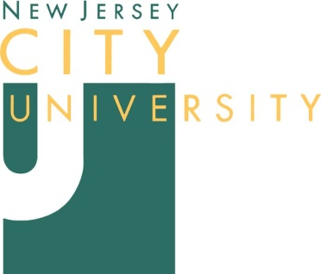
Department of Counselor Education
2039 Kennedy Boulevard, Rossey Hall 536
Jersey City, NJ 07305-1597
Phone 201-200-3400/Fax 201-200-3405

Health Resources and Services Administration (HRSA)
Behavioral Health Workforce Education and Training (BHWET) Stipend Program Spring 2019 - Fall 2019

Recommendation Form

Applicant’s Name:
Complete Address:

Home/Cell Number:
NJCU Email: Personal Email:
Under the Family Educational Rights and Privacy Act of 1974, enrolled students have access to their individual educational records. Students are also permitted to waive their rights of access to recommendations. Check one below:

I hereby WAIVE my right of access to review this recommendation.

I DO NOT WAIVE my right of access to review this recommendation.

Student’s Signature Date

To the Recommender: The applicant named above is applying for the HRSA-BHWET Stipend program with the Department of Counselor Education at NJCU. The selection committee would appreciate your assessment of the applicant to assist us with the review process.

Name of Recommender Date

Familiarity with the applicant:

- How long and in what capacity have you known the applicant?

- I know the applicant (check one): Very well Moderately well Other:

- Please use the following rubric to rate the applicant’s specific qualities (please compare the applicant with other graduate level counseling students while providing your ratings):
Qualities | Highest 2% among all students | Highest 5% among all students | Highest 10% among all students | Highest 25% among all students | Around 50% among all students | Lower than 50% among all students
Congruence & Genuineness
Counseling Skills
Professional Ethics
Professionalism
Motivation to Learn and Grow Initiative
Emotional Stability and Self-control
Self-awareness and
Self-understanding
Openness to Feedback
Flexibility & Adaptability
Commitment and Determination
Ability to Work with Diverse Population

- To the best of your knowledge and understanding of the abilities needed to succeed in a HRSA-BHWET Stipend Program, do you recommend this student as a grant recipient?

Recommend

Recommend with reservation (enclose comments)

Do not recommend
Please make any additional comments below or attach a separate sheet on letterhead.

Name: Title:
Institution Name:
Phone: Email:

Recommender’s Signature Date

RETURN COMPLETED FORM TO:
Anwaar Z. Najmi, HRSA Program Assistant
New Jersey City University
Department of Counselor Education
2039 Kennedy Blvd., Rossey Hall 536
Jersey City, NJ 07305-1597
Email: anajmi@njcu.edu or Fax: 201-200-3405

